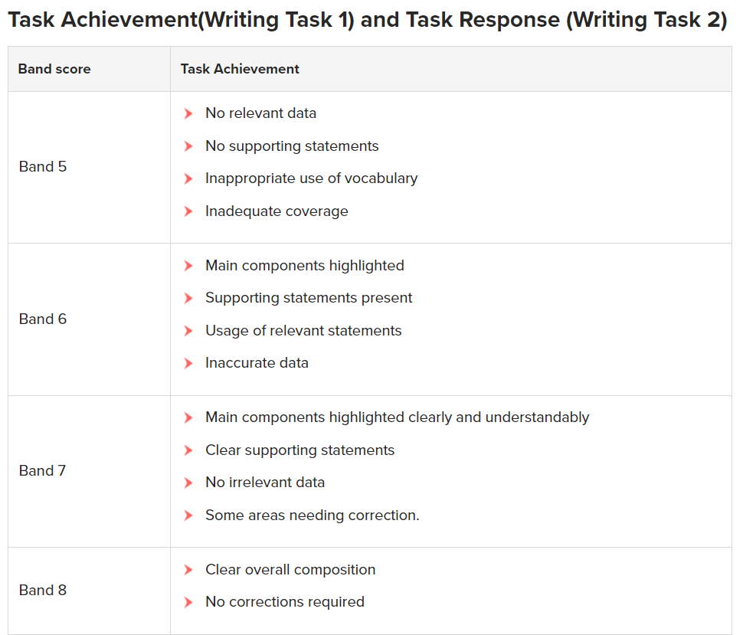

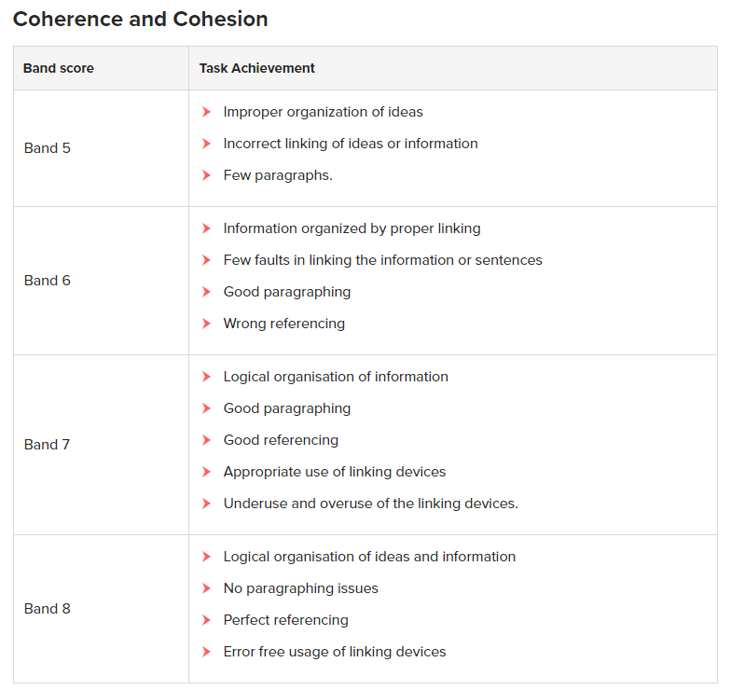 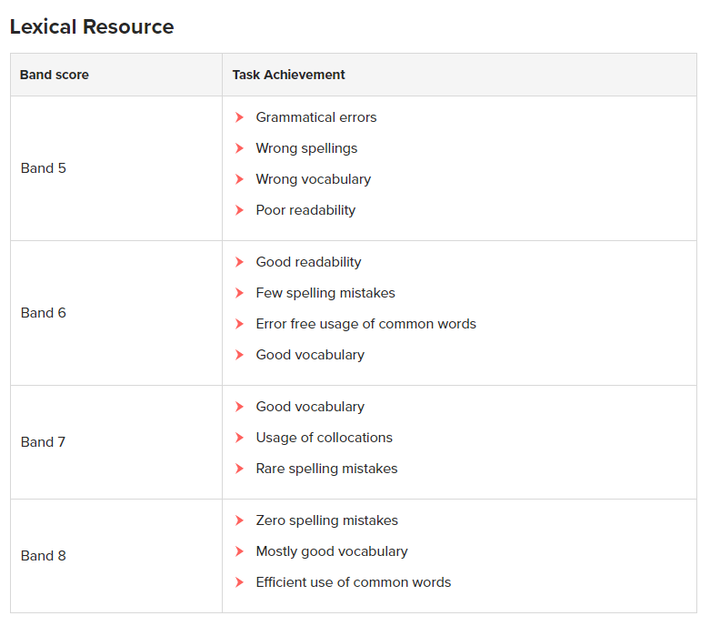 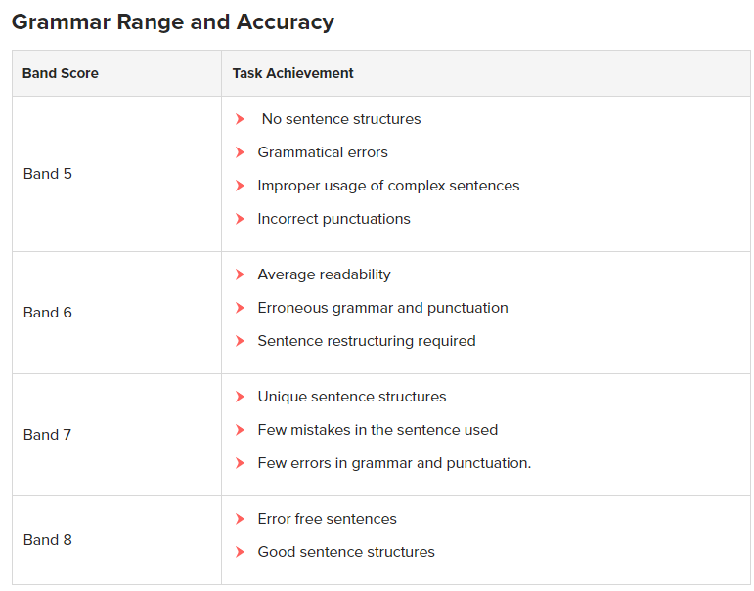

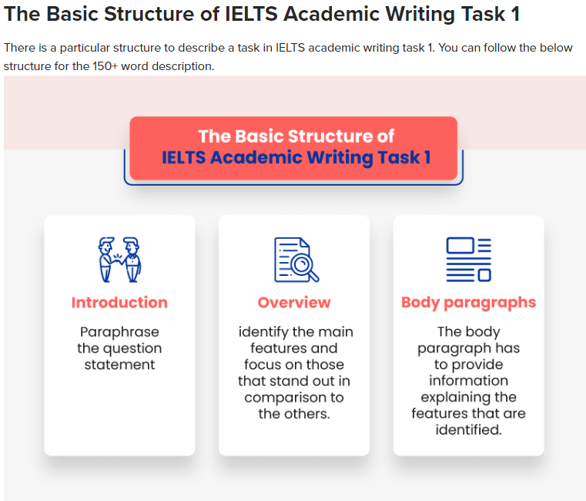

**Introduction**

Like an essay, the description too needs an introduction. Points to remember when you write an introduction:

* This paragraph should focus on the components of the graph/bar chart/ table/ process/map etc.
* To write this paragraph, you should read and understand the question given.
* Do not use the exact words given in the question, instead paraphrase the question.
* Using synonyms for the important words given in the question could get you extra points!
* If there is a time frame mentioned, do not forget to mention the time frame in your paragraph.

**Overview:**

The overview paragraph stands true to its name. In general terms, you must be able to identify the main features and need to focus more on them so that you can score a high band. **Points to remember when you write an overview:**

* This is an important paragraph.
* Identify the key features of the graph (highest point, lowest point, etc.)
* Focus on the features that stand out in comparison to the other features.

#### Specific Body Paragraphs

The 2 body paragraphs have to provide information explaining the specific features that are identified. **Points to remember when you write a paragraph:**

* You will have a **minimum of two specific comparison paragraphs discussing** information/data given.
* Use appropriate vocabulary to compare and describe the data.
* Check if the graphs follow a pattern (mostly [line graphs](https://ieltsmaterial.com/ielts-writing-task-1-line-graph/)/[bar charts](https://ieltsmaterial.com/ielts-bar-chart/)) and make sure you mention the pattern.